**UDID for iOS –**

In order to test on devices using the .ipa,

Provisioning profile must include client's device UDID.

**Steps**

1. Connect your device to iTunes
2. Click the Summary tab
3. Top area click on the “Serial number”

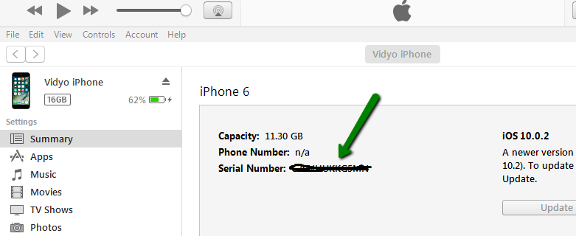

1. Once clicked UDID will reveal –

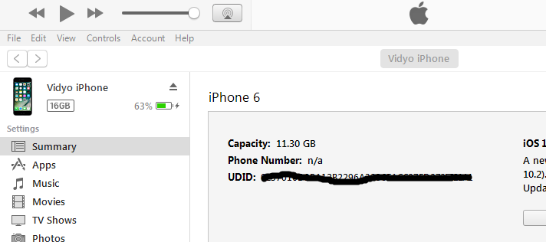

Provide the UDID to the developers in order to add to the provisioning profile list.